Beat the System: Spend Analytics vs Big Grocery

## Specially Designed Cost-Saving

I'm delighted to invite you, my esteemed “trusted circle”, to join a pioneering beta trial. This initiative uses Tesco Clubcard data not just to understand consumer behaviour & relationships, but to directly enhance your shopping experience.

## Your Benefits

* Insightful Savings: Explore your spending habits with personalised visualisations. Identify trends and discover areas where you could significantly reduce expenses!  
  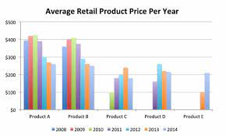
* Contribute to Innovation: Your participation aids groundbreaking research, mapping out new ways to interpret consumer data.

## Getting Involved in 3 Steps

1. Visit [Tesco Data Portability Request](https://www.tesco.com/account/data-portability/en-GB/requests/new?success=true) and log in.
2. Choose "Third Party" and input Benedict Summers & [benedict.s@hotmail.co.uk](mailto:benedict.s@hotmail.co.uk)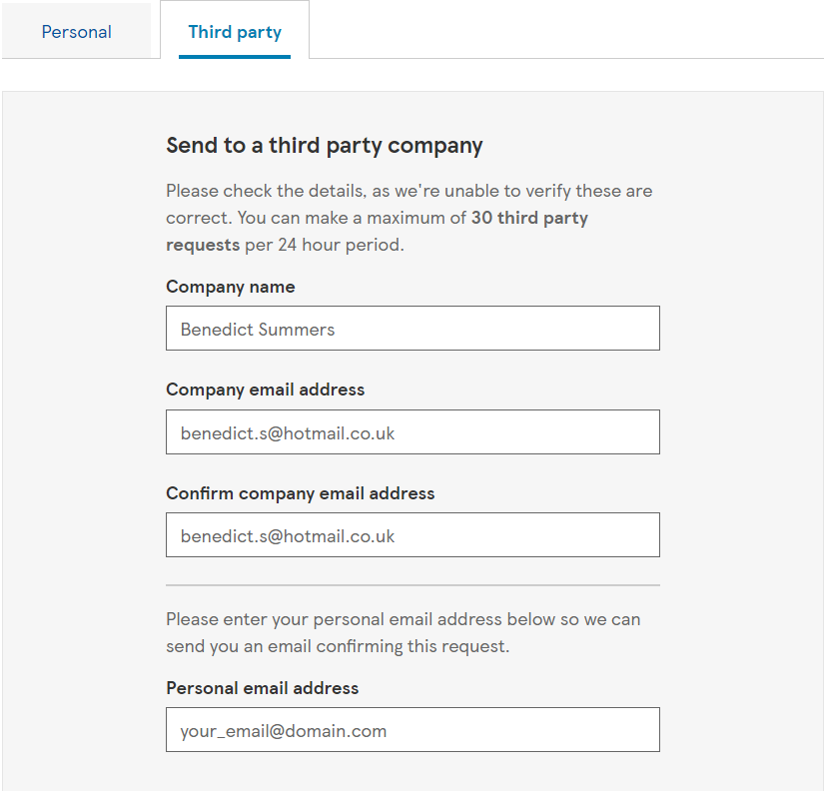
3. Click "Request," receive a code, and share it via [email](mailto:benedict.s@hotmail.co.uk)

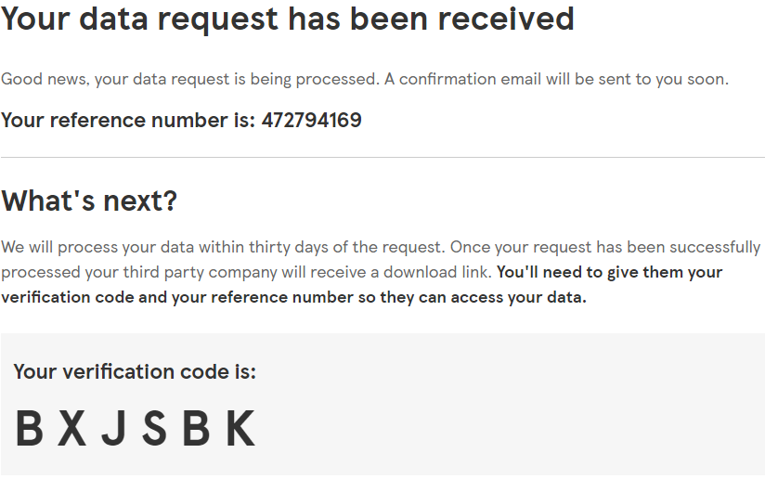

## Privacy Matters

Rest assured, all data is automatically anonymised to ensure confidentiality.

## Thank You And Enjoy!

Your participation is genuinely appreciated. You're not just joining a trial; you're stepping into a space where your insights could lead to new discoveries. Should you have any questions or need further details, I'm here for you.

Notes:

* Emphasise what the consumer actually gets for this
* Ensure they know exactly what they will gain from sharing
  + Categorise the data into snacks, auxiliary, stationery etc
  + Show groupings on what they save
    - Can use this to estimate what they could save
  + Also look into what temporal analysis might help them
    - But less frequently
* When I have multiple schemes (nectar, Tesco etc)
  + Do some sort of price comparison to estimate their savings
* Currently, this is halfway between “do me a favour” and “this is what you get”
  + Need it to fully be “this is what you get”
  + Then they WANT to follow the instructions
* Auto search line item on web & save results in file to get context & info on it
* Create low token prompt
  + Take in item name & search result
  + Take in predefined categories
    - L1/L2/L3
      * Maybe only L3 & L1/2 can be mapped from this
  + Ask llm to only use search result info
  + Output result in structured file